11. Map Coloring Problem using the Constraint Satisfaction Problem (CSP)

Aim
To implement the Map Coloring Problem using the Constraint Satisfaction Problem (CSP) approach.

Algorithm
- Define the map and neighboring regions.
- Define the available colors.
- Assign colors to each region.
- Ensure neighboring regions do not have the same color.
- Display the valid color assignment.
Pseudocode
Start
Define regions and colors
For each region
Assign a valid color
Check neighboring regions
Display color assignment
Stop
Code:
colors = ["Red", "Green", "Blue"]

graph = {
"A": ["B", "C"],
"B": ["A", "C", "D"],
"C": ["A", "B", "D"],
"D": ["B", "C"]
}

result = {}

def solve(region):
if region == len(graph):
return True

node = list(graph.keys())[region]

for color in colors:
valid = True

for neighbor in graph[node]:
if result.get(neighbor) == color:
valid = False
break

if valid:
result[node] = color

if solve(region + 1):
return True

del result[node]

return False

solve(0)

print("Color Assignment:")
for region in result:
print(region, "=", result[region])
Output:
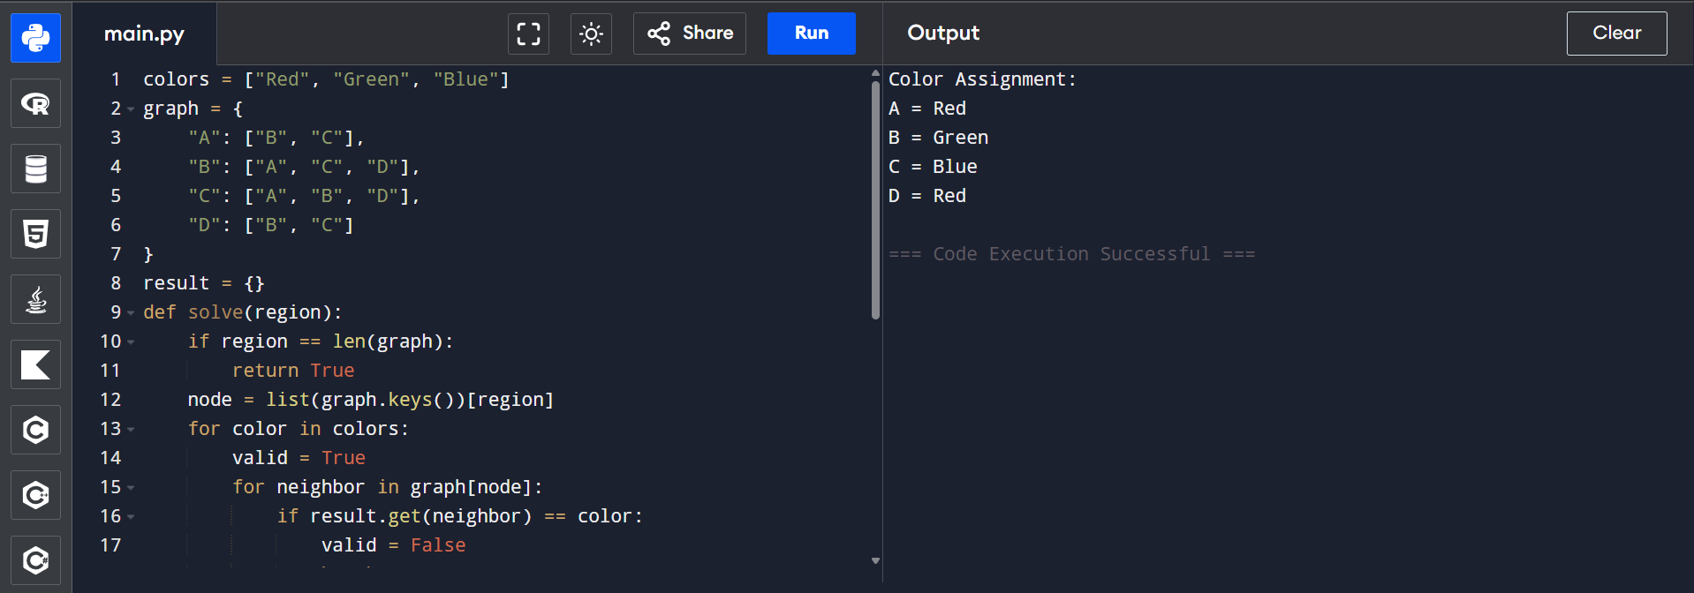

12. Tic Tac Toe game

Aim
To implement a simple Tic Tac Toe game using Python.

Algorithm
- Create a 3×3 board.
- Display the board.
- Allow players X and O to enter positions.
- Update the board.
- Continue until all moves are completed.
Pseudocode:
Start
Create empty board
Repeat
Get player move
Update board
Display board
Until game ends
Stop

Code:

board = [" "] * 9

def display():
print(board[0], "|", board[1], "|", board[2])
print("--+---+--")
print(board[3], "|", board[4], "|", board[5])
print("--+---+--")
print(board[6], "|", board[7], "|", board[8])

for i in range(9):
display()
player = "X" if i % 2 == 0 else "O"
pos = int(input(f"Player {player}, Enter position (1-9): ")) - 1

if board[pos] == " ":
board[pos] = player
else:
print("Position already occupied!")

display()

Output:
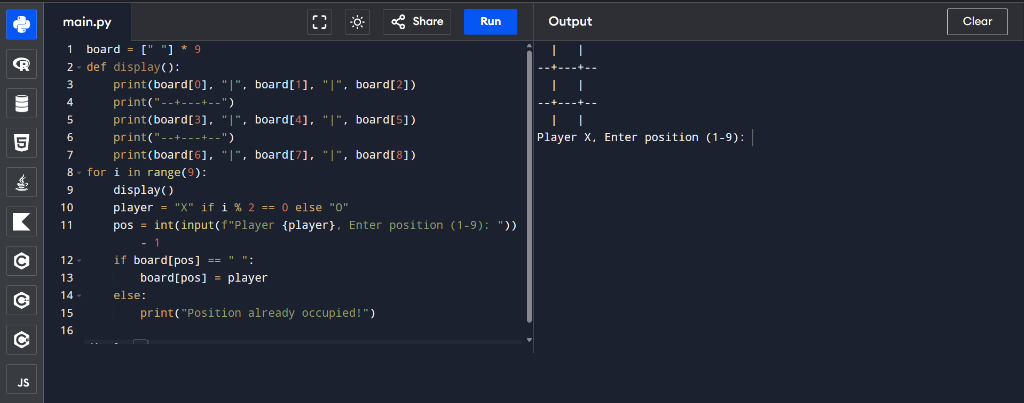

13. Minimax Algorithm for Gaming

Aim
To implement the Minimax Algorithm for selecting the best move in a game.

Algorithm
- Define the game tree values.
- If it is the maximizing player's turn, choose the maximum value.
- If it is the minimizing player's turn, choose the minimum value.
- Continue recursively until leaf nodes are reached.
- Display the optimal value.

Pseudocode
Start
If leaf node
Return value

If maximizing player
Return maximum child value

Else
Return minimum child value

Stop

CODE:
def minimax(depth, node, isMax, values):

if depth == 3:
return values[node]

if isMax:
return max(
minimax(depth + 1, node * 2, False, values),
minimax(depth + 1, node * 2 + 1, False, values)
)
else:
return min(
minimax(depth + 1, node * 2, True, values),
minimax(depth + 1, node * 2 + 1, True, values)
)

values = [3, 5, 2, 9, 12, 5, 23, 23]

print("Optimal Value:", minimax(0, 0, True, values))

OUTPUT:
